*Curriculum vitae*

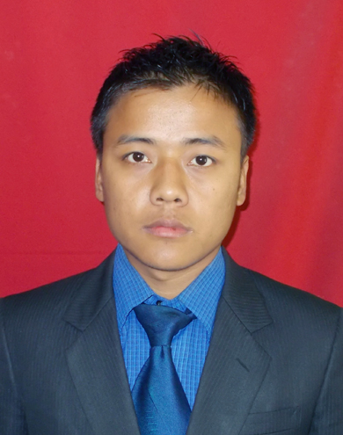**LALBIAKMUANA HAUHNAR**

***Career Objective***: Seeking a position with a growth oriented organization in the Industry providing good opportunity for enhancement of professional and personal skills, while being resourceful, flexible and innovative for the organization.

# **Profile Summary**

* MBA (Marketing and Finance) from Department of management, Mizoram University- A central university with **NAAC “A” accreditation 2014**
* Bachelor of Business Administration ICFAI University Aizawl
* Excellent in interpersonal skills and communications.

# ***Personal Profile***

***Name*** : **Lalbiakmuana Hauhnar**

***Father’s name*** : H. Haudingzela

***Address*** : House No: 88 Venghlun Lunglei Mizoram

Pin: .797001

***Phone No***  : +918729917764

***E-Mail Address*** : [bmahauhnar@gmail.com](mailto:bmahauhnar@gmail.com)

***Date of Birth*** : 10th September 1992

***Sex*** : Male

***Marital Status*** : Single

***Nationality*** : Indian

***Languages Known*** : **English, Mizo**

# ***ACADEMIC PROFILE***

|  |  |  |  |
| --- | --- | --- | --- |
| **Qualification** | **University/Board** | **Year** | **Percentage/SGPA** |
| **MBA ( Marketing & Finance)** | Department of Management ,Mizoram University | 2015 | SGPA.  1stSem- 7.40  2ndSem- 7.56  3rd Sem-7.76  4th Sem-7.61 |
| **BBA** | Institute of Chartered Financial Analyst of India University Mizoram | 2012 | 76.7% |
| **HSSLC** (12th) | Mizoram Board of School Education (Baptist HSS Serkawn) | 2010 | 57.6%  46.60 |
| **HSLC** (10th) | Mizoram Board of School Education | 2008 | 63% |

# ***Computer Skills***

Well versed with various computer applications Excel, PowerPoint, and Word etc. Abilitiy to get meaningful information from the internet. Committed to continuously learn and develop in the subject.

|  |  |
| --- | --- |
|  |  |

# ***Industrial Training/ Internship***

1. ***Organization* :** **Private Institution Lunglei District**

***Topic* : A study on recruitment and selection process of different**

**Private Institution**

***Training Duration* : 61 days (24-09-2012 – 23-11-2012)**

1. ***Organization* :**  **State Bank of India**

***Topic* : A study on customer perception towards advance products and services provided by SBI Lunglei**

***Project Duration* : 40 days (22-07-2014 – 30-08-2014)**

# ***Seminar/workshop Attended***

* National Seminal on **“Branding North-East India for Tourism Destination”** Organized by Dept of Management, Mizoram University (March 2014).
* UGC National seminar on “**Women Entrepreneurship in Northeast India**” at Mizoram University, (February 2014)
* Workshop on “**Basics of Photography**” organized by department of management, Mizoram university (September 2014)

# ***Membership/Recognition***

* Active member of Social awareness and Innovation club in Department of management, Mizoram university

*I hereby declare that the information given herewith is correct to my knowledge and I will be responsible for any discrepancy.*

Sd/-

Date: 24/03/2015

Place: Aizawl Lalbiakmuana Hauhnar